Project Development Phase
Model Performance Test

Date | 03 October 2026
Team ID | SWTID-2026-5003
Project Name | Implement Client Script and UI Policy (Incident)
Maximum Marks | Not specified

Model Performance Testing:
Prepared for the project team. The report uses available configuration screenshots; no formal performance measurements or signed test results were supplied. Team: Kaleeswari G (Team Leader: Milestones 4 and 5, Milestone 6 Activity 1); Devibala. A. S (Milestones 1 to 3); Karthika. M (Milestone 6 Activities 2 to 4); Amirtha Varshini S (Milestone 6 Activity 5 and conclusion).
S.No. | Parameter | Screenshot / Values
1. | Data Rendered | No Power BI dataset or report is included. ServiceNow Incident form/list evidence is shown.  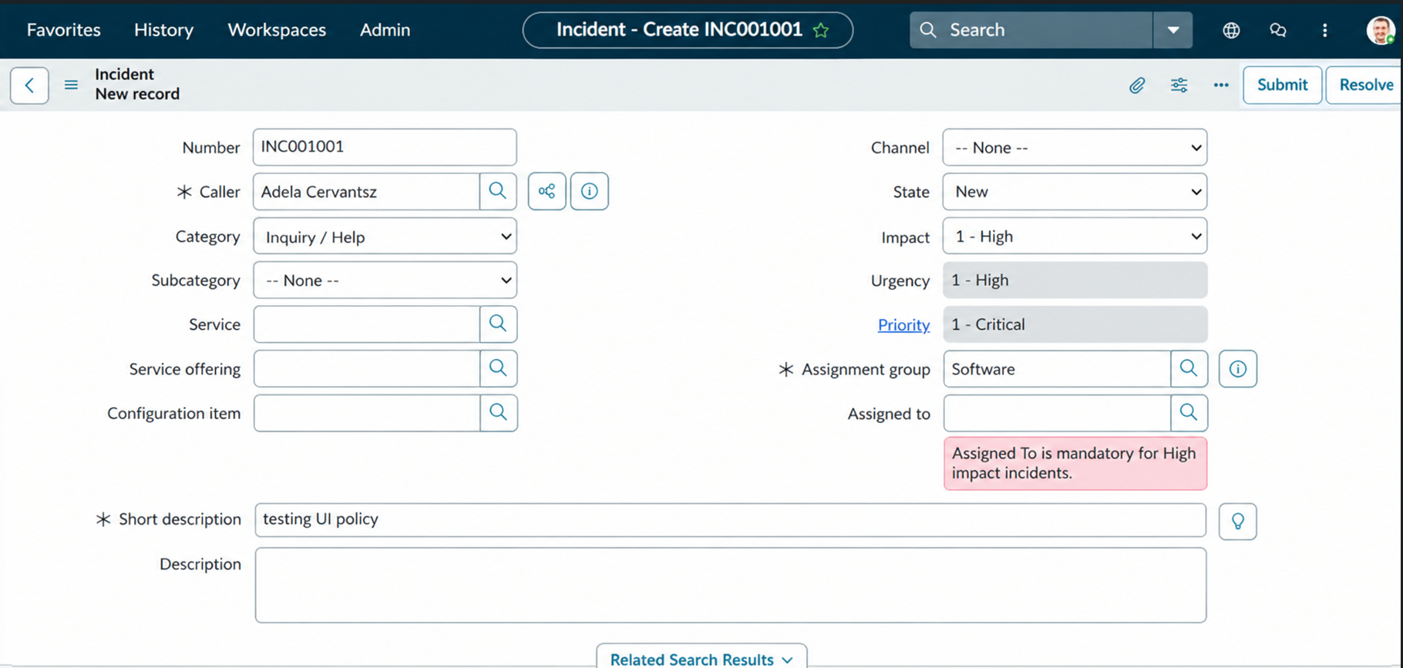
2. | Data Preprocessing | No BI dataset preprocessing is performed. Project behavior is configured on the Incident form.  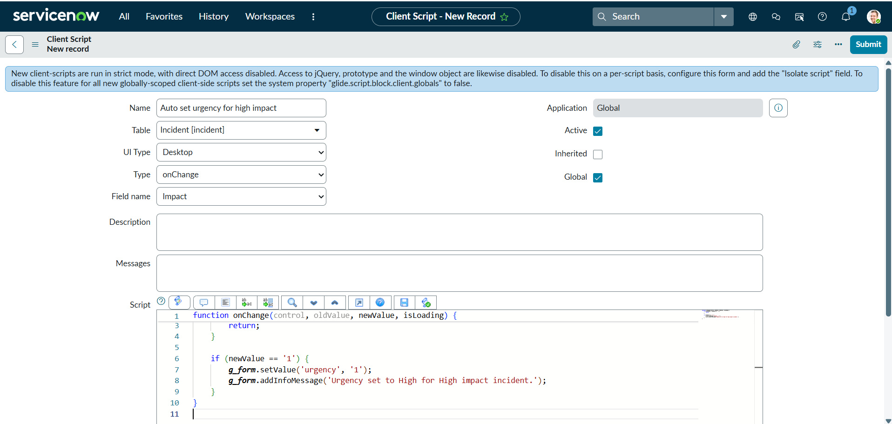
3. | Utilization of Data Filters | No Power BI filters are used. Closest project rule is the UI Policy condition Impact = 1 (High).  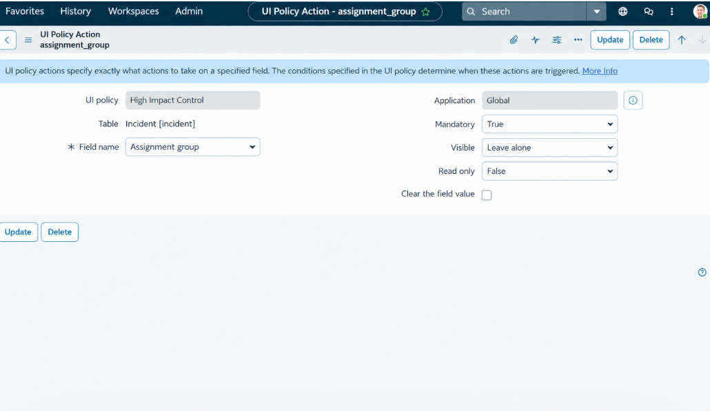
4. | DAX Queries Used | Not applicable. The project uses ServiceNow client-side JavaScript, not DAX.
5. | Dashboard design | Not applicable. No Power BI dashboard or visualization count is supplied.
6. | Report Design | Not applicable. No Power BI report is part of the project.

